|  |  |  |
| --- | --- | --- |
|  | **2025 CMAS European Championships  Underwater Rugby**  **10th to 15th November 2025**  **Athens (Greece)** |  |

**ADDITIONAL INFORMATION**

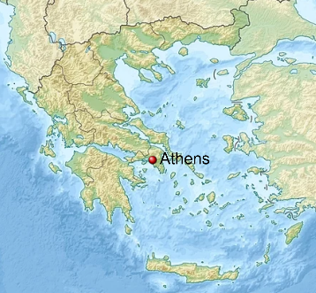**The city of Athens**

Athens is the capital of Greece. The municipality of Athens has a population of around 600.000 inhabitants, but the so-called Greater Athens along with Piraeus has around 3 million inhabitants. Athens was also at the heart of Ancient Greece, a powerful civilization. The city is best known for Acropolis, a hilltop citadel topped with ancient buildings like the colonnaded Parthenon temple and is a world center of archaeological research. Piraeus is the largest container transport port in the Mediterranean, and the largest passenger port in Europe. Athens has an underground railway system (Athens Metro), several tram lines and a wide network of bus lines.

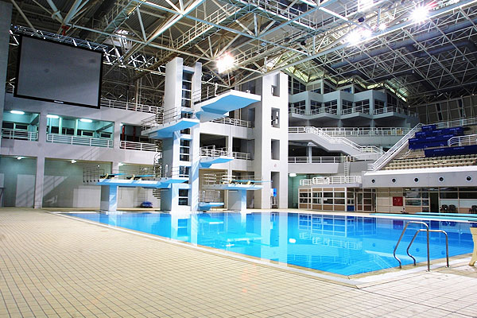**The Olympic Aquatic Center**

The Athens Olympic Aquatic Center, part of the Athens Olympic Sports Complex, is a world-class facility that hosted aquatic events during the 2004 Summer Olympics. It features multiple pools, including an Olympic-size swimming pool, a water polo pool, and a dedicated diving pool. The diving pool stands out for its 10-meter-high platform, multiple springboards, and advanced water circulation system, ensuring optimal conditions for divers. The dimensions of the diving poos are: 25m x 21m x 5m. Designed to meet international competition standards, the venue witnessed thrilling performances in synchronized and platform diving.

The **Athens Olympic Aquatic Center** is located in **Marousi**, a northern suburb of **Athens, Greece**. It is approximately **10 kilometers (6 miles) from the city center**, making it easily accessible by **metro (Line 1 – Eirini Station), buses, and taxis**.A large indoor swimming pool with people in the background

In May 2025 the CMAS World Championship Freediving Indoor will be hosted in the indoor swimming pool of the Olympic Aquatic Complex.

*You may find more photos of the pool at the end of this document.*

**Transportation**

Athens has an international airport (Athens International Airport “Eleftherios Venizelos”), which is located near the city of Spata. It is around 45 min away from the city center (Syntagma square) with the public transportation and 33 min by car. The Athens Olympic Aquatic Center is easily accessible from the airport as it is only 25min away by car.

**Accomodation**

Athens is a very popular destination for vacation and holidays and has numerous accommodation possibilities. Depending on whether a team prefers to reside near the touristic city center or near the pool there are the following suggestions*:

**Accommodation possibilities near the swimming pool:**

1. **Vivo apartments**

Address: 53 Neapoleos str. 15123

Distance from the pool: 20 min on foot

Contact: https://www.vivoapartments.gr/

Price: 30-40€/person/night

1. **Omorfoklissias apartments**

Address: 25 Omorfokklisias str. 15122

Distance from the pool: 20 min on foot

Contact: <https://www.verdeapartments.gr/>

Price: 30-40€/person/night

1. **Wellnest Hotel**

Address: 12 Flemingk, 15123

Distance from the pool: 24 min on foot / 8 min by car

Contact: +30-[21 0682 8577](https://www.google.com/search?client=firefox-b-d&q=welnest+hotel+flemingk)

Price: 50-60€/person/night

**Accommodation possibilities near the touristic city center:**

1. **Crown Plaza Athens City Center**

Address: 50 Michalakopoulou str., 11528 Athens

Stars: 5

Distance from the pool: 20 min by car (depending on traffic)

Contact: +30-2107278000, www.cpathens.com

Price: around 90-110€/person/night

1. **Athenian Foss**

Address: Evaggelistrias 9 & Ermou, 10563 Athens

Stars: N/A

Distance from the pool: 25 min by car (depending on traffic)

Contact: +30-2103216300, [info@athenianfoss.gr](mailto:info@athenianfoss.gr), <http://athenianfoss.gr>

Price: around 45-55€/person/night

1. **Klepsydra Urban Suites**

Address: 1 Aristidou str., 10559 Athens

Stars: N/A

Distance from the pool: 25 min by car (depending on traffic)

Contact: +30+30-2107001724, https://klepsydrasuites.com

Price: around 45-55€/person/night

**Hostels**

1. **Pella Inn Hostel**

Address: 104 Karaiskaki str., 10554 Athens

Distance from the pool: 30 min by car (depending on traffic)

Contact: +30-2103250598, https://www.pellainn.com/

Price: around 15-20€/person/night

1. **Athens Hub Hostel**

Address: 7 Agias Eleousis str., 10554 Athens

Distance from the pool: 35 min by car (depending on traffic)

Contact: +30-2103254754, https://athenshubhostel.com

Price: around 30€/person/night

*\* The prices are indicative and the organizer bears no responsibility for the correctness of the information as well as for possible differences from the actual prices. Please keep also in mind that we are still under negotiations for better prices with some of the above-mentioned hotels.*

*[Photos following on the next page]*

**Additional photos of the Olympic Aquatic Center**

